Chapter 6, Problem 16.

The equivalent capacitance at terminals a-b in the circuit in Fig. 6.50 is 30 μF. Calculate the value of C.

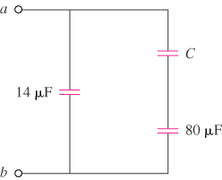

Figure 6.50
For Prob. 6.16.

